

Central Midlands Regional Transit Authority

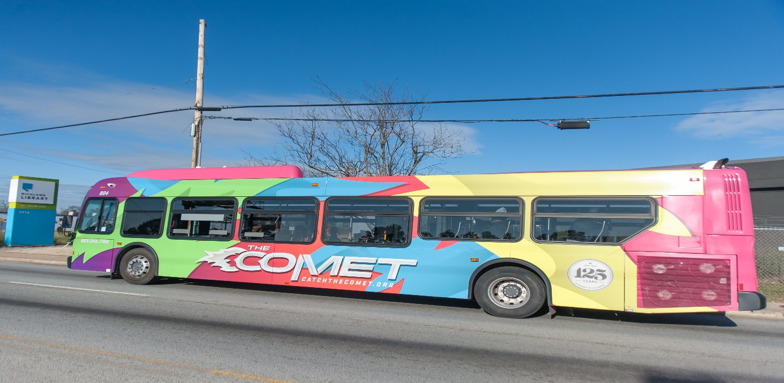

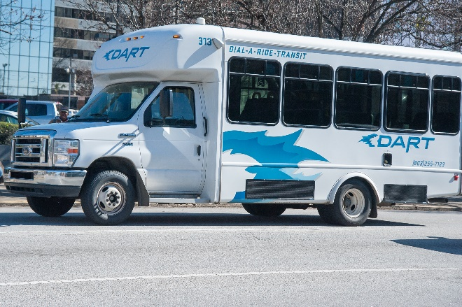 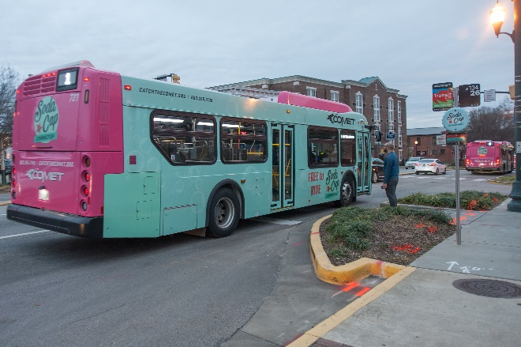

**Fiscal Year 2019-2020 Budget**



May 17, 2019

Dear Honorable Members of the Board of Directors,

This budget document is my first since becoming Executive Director/CEO/CEO of the Central Midlands Regional Transit Authority (The COMET). The previous fiscal year had its successes and challenges as The COMET continues to manage its public transit system throughout Richland and Lexington Counties. From the past year, there was continued increase ridership growth, addition of new advisory members from the Cities of West Columbia and Cayce, Towns of Springdale and Eastover and new partnerships were formed with Richland One, Nephron Pharmaceuticals, Riverbanks Zoo & Garden, Midlands Technical College, City Center Partnership, Experience SC, Foodshare, Richland Library, Central Midlands Council of Governments and various associations and chambers of commerce’s to support and increase awareness of The COMET services. The COMET also implemented new mobility management strategies such as partnerships with Lyft and Uber, Commute with Enterprise and Blue Bike. The COMET is more than just fixed route buses and ADA paratransit services.

South Carolina Code of Law Chapter 25, Section 58-25-70 requires The COMET, as a regional transportation authority, to submit to the member municipalities and counties the annual operating and capital budget proposed for each fiscal year, at least sixty days (60) prior to the beginning of the fiscal year. This proposed operating and capital budget document is to achieve the intent of this section. It is my pleasure to present the Fiscal Year 2019-2020 budget for Central Midlands Regional Transit Authority.

This budget continues the endeavor to maintain our current operations. Any expansion would be borne by pursuit of new grants or funding sources as well as continued service planning to improve the efficiency of the transit system. In order to provide a total picture of The COMET, this budget document encompasses all of the activities under the jurisdiction of The COMET Board of Directors. The budget assumes that approximately 185,000 revenue hours for fixed route, 16,000 revenue hours for flex routes and 39,000 revenue hours for DART paratransit services will be provided in fiscal year 2019-2020. Transdev’s rate will increase by CPI Index of 1.5% with a $1.54 adder, per fixed route hour operated. Their contract expires at the end of June 30, 2020 with an option to extend up to five (5) one-year extensions through June 30, 2025.

Service enhancements are funded by Federal Transit Administration (FTA) funding in the amount of $1,500,000 to cover Transdev’s operational costs. This will allow for the addition of a new route along Trenholm Road, a rural route to Batesburg/Leesville and an express route to Lower Richland area. It is projected that two additional regular fixed routes may be converted to ReFlex routes and subcontracted to the DART operator this fiscal year to reduce costs based on the productivity of those routes. In addition, $455,572 of FTA funding will cover DART ADA paratransit expenses. This offset allows for additional services to be provided in both Richland and Lexington Counties, and the building of a reserve of the Richland County Transportation Penny. Beyond the service levels of fiscal year 2019-2020, there are no additional funds to expand service unless another source of operational funds are provided to The COMET or lower productive routes are discontinued.

The budget is based on known revenue amounts that have been committed. Revenue amounts are always subject to change and staff will keep the Board of Directors apprised on any changes based on decisions made by local, state and Federal agencies. Known revenue amounts include FTA, member agency contributions from the municipalities, miscellaneous revenues, farebox revenues and pass revenues based on memorandum of understandings exercised with various social service agencies.

There will be a slight increase in local match revenues due to a 1.5% increase in the Transdev contract. This increase will be passed to member jurisdictions in Lexington County as well as any contractual service provided. Staffing will be reduced from 13 employees to 11 employees, plus one employee contracted to a social service agency and will be funded through FTA Section 5310 funding. This is from a reorganization last fiscal year to ensure all areas of the administering agency, such as The COMET is covered. Many duplicative functions provided by The COMET and its contractors or consultants have been eliminated. Professional services will slightly decline due to many contracts being re-procured in the prior fiscal year with defined pricing.

All these efforts are contained within a budget that maintains a stable financial footing for this fiscal year. Given our heavy reliance upon member agency contributions, this budget assumes limited growth in member agency contributions by CPI and continues to seek additional funding from external partners, other educational institutions and employers.

As The COMET moves into the future, this budget will take into consideration the overall review of how The COMET does business. While there is ample funding for today’s operations, the largest funding source, the Richland County Transportation Penny is capped at $300,991,000 or 22 years (2035). The COMET projects that the funding cap will be reached in the start of fiscal year 2028-2029 with reserves to last through the end of that fiscal year. The COMET will spend the next upcoming fiscal year to engage the community and build support for the transit system. This will involve increased marketing and community awareness, study of The COMET’s business practices and routes through a comprehensive operational analysis, development of mobility management strategies, adding passenger amenities and discussions on addressing future funding and governance of the regional transportation authority. There will be a renewed effort to make the transit system fast, fun, friendly and frequent by redirecting existing resources.

While there are unmet transit needs in Richland and Lexington Counties, The COMET does not have the resources to implement these needs at this time and it is very prudent that the resources available are utilized in the appropriate manner consistent with the Vision 2020 and Compass Strategic Plan to ensure that the promise has been delivered to Richland County taxpayers. This will ensure creditability should The COMET be successful in requesting Richland County to consider a seven-year extension of the Penny Program.

For a second year in a row, The COMET’s financial successes and complex grant management successes goes to Rosalyn Andrews, The COMET’s Director of Finance/CFO and Michelle Ransom, the Grants & Regional Coordination Manager in being able to manage The COMET’s finances in a manner to allow for our continued fiscal sustainability and to The COMET’s Finance Committee, including its previous Chair, Andy Smith, current Chair, Dr. Robert Morris and its members, Joyce Dickerson, Jacqueline Boulware, Leon Howard and Col. (R) Roger Leaks, Jr. in ensuring the limited funds needed to operate The COMET is managed in the most prudent possible way.

Being 18 years old as a government agency and The COMET transit system being around for 127 years through its predecessors together, we will continue to experience a much smoother road and clearer skies in fiscal year 2019-2020 as we continue to encourage Central Midlands residents and visitors to Catch The COMET!

Should you have any questions regarding this budget report, please contact me at (803) 255-7087 or email me at [jandoh@TheCometSC.](mailto:jandoh@TheCometSC.)gov or Rosalyn Andrews, Director of Finance/CFO at (803) 255-7135 or email [randrews@TheCometSC.](mailto:randrews@TheCometSC.)gov.

Sincerely,

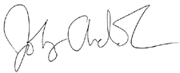

John C. Andoh, CCTM

Executive Director/CEO/CEO

Central Midlands Regional Transit Authority John Andoh, CCTM, CPM Executive Director/CEO

3613 Lucius Road, Columbia, SC 29201 Ron Anderson, Chair, John V. Furgess, Sr., Vice Chair

P 803 255 7133 F 803 255 7113 Andy Smith, Secretary, Dr. Robert Morris, Treasurer

*CATCHTHECOMETSC.GOV* **Board Members:** Jacqueline Boulware, Lill Mood,

[*info@TheCOMETSC.gov*](mailto:info@TheCOMETSC.gov)Carolyn Gleaton, Leon Howard, Derrick Huggins,

Col. (R) Roger Leaks, Jr., Joyce Dickerson, Skip Jenkins, Debbie Summers, Bobby Horton, Kevin Reeley, Geraldine Robinson, William (B.J.) Unthank



**Introduction**

Per the South Carolina Code of Laws – Chapter 25 – Regional Transportation Authority Law, Central Midlands Regional Transit Authority is required to present and seek concurrence of annual budget by the member governments, at least 60 days prior to the beginning of the fiscal year.

**SECTION 58-25-70. Recordkeeping and reporting; proposal and approval of budgets.**

The authority must keep books of account, which must be independently audited at least once in each calendar year. A copy of the audit report must be provided to the member municipalities and counties. The authority must make an annual report of its activities to the member municipalities and counties. The authority must submit to the member municipalities and counties the annual operating and capital budget proposed for each fiscal year, at least sixty days prior to the beginning of the fiscal year. In the event a member municipality or county disagrees with the proposed budget, it may set forth points of disagreement and transmit its statement to the authority and other governing bodies of the member municipalities and counties within thirty days of the receipt of the proposed budget. Budgets must be adopted by a majority of the member governments. In the event a majority of the governing bodies of the member municipalities and counties do not agree with the proposed budget, the authority must convene a meeting of chief elected and administrative officials of member governments to develop a budget which may be acceptable to a majority of the member governments; a majority, for the purposes of this section, includes the governing bodies of the member municipalities and counties representing more than one-half of the service area population. In the event a budget acceptable to a majority of the member governments is not developed prior to the beginning of its fiscal year, the authority shall continue to operate at the budget levels of the previously approved budget. Any budget changes requiring an increase in local funds in excess of ten percent during the budget year must be approved as provided above for annual budgets.

*HISTORY: 1962 Code Section 59-127; 1973 (58) 726; 1985 Act No. 169, Section 2, eff July 1, 1985; 1997 Act No. 43, Section 6, eff May 21, 1997.*

The following is an overview of the revenues and expenses for The COMET for its 2019-2020 fiscal year. The fiscal year encompasses the period from July 01, 2019 through June 30, 2020. Total budgeted operating & capital revenues increased by 13% and expenditures increased by 8% from the FY 2018-2019 adopted budget. Specific details regarding the increase in the operating budget are outlined later in this publication.



**The Organization**

The COMET is a regional transportation authority formed by Richland County, City of Columbia and Lexington County on April 24, 2000 by the Central Midlands Council of Governments. In May 2001, The COMET Board of Directors held its first meeting. On October 16, 2002, The COMET assumed operations of the bus services provided by South Carolina Electric and Gas Company whom was utilizing a private contractor.

The COMET consists of an intergovernmental agreement signed by Richland County, City of Columbia, City of Forest Acres and Lexington County to fund, operate and maintain public transit services in the Central Midlands area. The intergovernmental agreement took effect in July of 2013 based on receipt of new funding from Richland County for 22 years or $300,991,000, whichever comes first.

The COMET Board of Directors sets overall policy and direction for the transit system. 11 voting Board Members representing the City of Columbia (3), Richland County (3), City of Forest Acres (1), Lexington County (3) and Richland County Delegation (1). Non-voting members include one (1) representative each from the City of Cayce, City of West Columbia, Town of Springdale, Town of Eastover, Lexington County Legislative Delegation and Lexington County. Board meetings are held the 4th Wednesday of each month. Committee meetings are held on the 2nd Wednesday of each month.

The COMET has 12 employees, overseen by an Executive Director/CEO with support from staff in the Finance, Regulatory Compliance & Civil Rights, Operations & Administration, Planning and Development departments.

Board Members

Ron Anderson - Chair John V. Furgess, Sr. – Vice Chair

Robert Morris -Treasurer Andy Smith - Secretary

Jacqueline Boulware Joyce Dickerson

Carolyn Gleaton Leon Howard

Derrick Huggins Col (R) Roger Leaks Jr.

Lill Mood Skip Jenkins*

Debbie Summers* Bobby Horton*

J. Kevin Reeley* Geraldine Robinson*

William (B.J.) Unthank*

(*Advisory members)

Senior Staff

John C. Andoh III - Executive Director/CEO

Rosalyn Andrews - Director of Finance/CFO

LeRoy DesChamps - Director of Administration& Operations/COO

Dr. Arlene Prince – Director of Regulatory Compliance & Civil Rights Officer

Donna “Michelle” Ransom - Grants & Regional Coordination Manager



**Motto, Mission, Vision & Core Values Statement**

**Motto**

*Catch The COMET…..We Will Get You There!*

**Mission Statement**

The COMET provides safe, reliable, efficient, and customer-friendly mobility services throughout the Midlands region and stimulates economic development and enhances quality of life.

**Vision Statement**

A high-quality public transit service that contributes to economic development, environmental sustainability and mobility solutions throughout the Midlands.

**Core Values**

* Safety
* Reliability
* Friendliness
* Cleanliness
* Cost Effectiveness

**Revenues & Expenditures Summary**

The total proposed budget for Fiscal Year (FY) 2019-2020 is ~$29.80 million, increasing $3.42 million or 13% from $26.38 million in FY 2019-2020. The table below provides the budgets major categories, percentage change from FY 2018-2019 to FY 2019-2020 and percent of revenue.



Funding for The COMET’s operation and capital cost are generated from several funding sources. The COMET’s main sources are: Passenger fares @ 9.13%, Federal Transit Administration (FTA) grants @ 23.24%, Richland County Penny tax revenue @ 63.27% and miscellaneous revenues (Lexington County, State, advertising, etc.) are 4.36% of the total proposed budgeted revenue anticipated to be received in FY 2019-2020.

The COMET’s expected capital projects for FY 2019-2020 are:

* Two diesel powered trolleys
* Two low-floor gasoline powered cutaways
* Continued renovation of Laurel & Sumter Street Transit Center
* New Intelligent Transportation System (ITS)
* Bikeshare stations in Downtown Columbia, Cayce and West Columbia
* Passenger amenities, including bus shelters, benches and bike racks
* Website redesign
* Mobility management
* Training and development of staff
* Computer hardware and software

The COMET’s expected operations projects for FY 2019-2020 are:

* Transit operations, marketing and administration in Richland and Lexington Counties
* Security on buses, transit center and bus stops
* Vanpool program
* Preventative maintenance of transit buses and facilities
* Lyft/Uber subsidy, Blue Bike, Volunteer transportation and subsidized taxi scrip program.







**The Funding Picture**

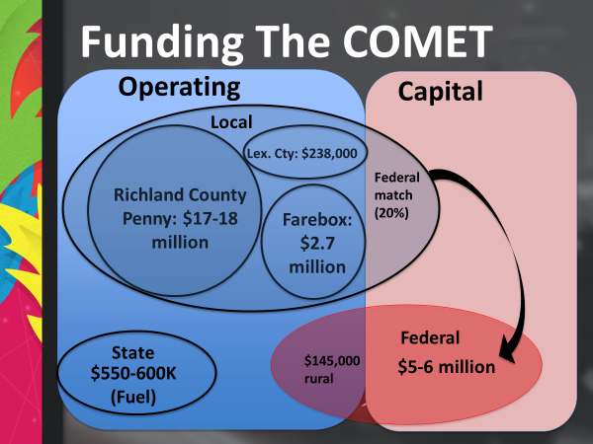

**Budget Line Details**

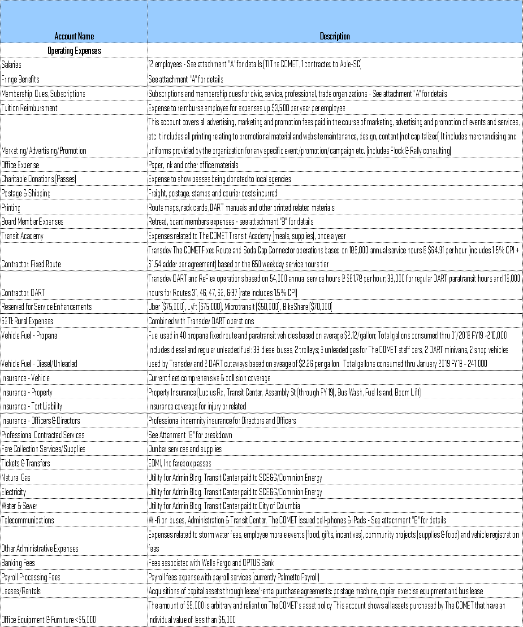



|  |  |
| --- | --- |
| **Attachment "A"** |  |
| **Select Expense Breakdown** |  |
| **Salaries 4101 & 4102** |  |
| Executive Director/CEO (Include incentive) | $ 153,363 |
| Director of Administration & Operations/COO | $ 92,452 |
| Director of Finance/CFO | $ 88,400 |
| Financial Accountant | $ 55,721 |
| Procurement Specialist or Contracts & Procurement Manager | $ 64,039 |
| Director of Regulatory Compliance & Civil Rights Officer | $ 88,400 |
| Grants and Regional Coordinator Manager | $ 87,448 |
| Transit Operations Specialist | $ 51,179 |
| Administrative & Customer Service Specialist | $ 35,693 |
| Mobility Management Specialist (Contracted through Able-SC) | $ 35,500 |
| Planning & Development Specialist | $ 54,891 |
| Marketing & Public Information Manager | $ 60,000 |
| Temporary Staff or Interns | $ 25,000 |
| Total | $ 892,087 |
|  |  |
| **Fringe Benefits - 4140 to 4167 (12 Employees)** |  |
| Dental ($15.00 per employee per month) | $ 1,980 |
| Vision (no employer cost) | $ - |
| Health | $ 61,149 |
| Health Insurance | $ 63,129 |
| Workers Compensation | $ 1,200 |
| SC Unemployment 3% | $ 6,500 |
| FICA 6.2% & Medicare 1.45% | $ 68,245 |
| SC Retirement (14.41+.56=15.56% of salaries) | $ 138,809 |
| Total | $ 277,882 |
|  |  |
| **Membership, Dues, Subscriptions - 4201** |  |
| APTA | $ 21,000 |
| GFOA | $ 300 |
| CTAA (Community Transportation Association of America) | $ 300 |
| TASC (Transportation Association of South Carolina) | $ 1,000 |
| CTE (Center for Transportation & the Environment | $ 3,000 |
| ZEBRA (Zero Emission Bus Resource Alliance) | $ 3,000 |
| ACT, SHRM, Sam's Club, Costco, Chamber, COMTO, Procurement, Vista, Five Points, other districts | $ 7,400 |
| Total | $ 36,000 |
|  |  |
| **Attachment "B"** |  |
| **Select Expense Breakdown** |  |
| **Board Member Expenses - 4210** |  |
| 12 Monthly Meetings - Luncheon | $ 4,500 |
| Board Member Training | $ 5,500 |
| Total | $ 10,000 |
|  |  |
| **Professional Contract Services - 4361** |  |
| Legal (Currently Burr Forman McNair) $1,000 per month, plus special projects | $ 37,000 |
| Extra Attorneys (Currently Robinson Gray, Riley-Pope-Laney Attorneys) | $ 75,000 |
| Audit Firm | $ 22,000 |
| Public Relations (Chernoff) $225.00 per hour | $ 60,000 |
| ADA Eligibility (Able-SC $80.00 per new applicant $60 per re-certification based on avg 550 new applications) | $ 44,000 |
| Engineering & Design | $ 100,000 |
| Other contractors for special projects | $ 134,430 |
| Total | $ 472,430 |
|  |  |
| **Telecommunications - 4383** |  |
| iPad data plan with Verizon (1 cell phone; 10 iPads) | $ 8,000 |
| The COMET cell phones (7 employees); wi-fi (Administration, Transit Center, Buses) (AT&T) | $ 76,100 |
| Total | $ 84,100 |
|  |  |
| **Security - 4363** |  |
| Columbia Police Department – 6 a.m. to 10 p.m., 363 days times $35.00 per hour (14 hours a day) | $ 177,870 |
| City Center Partnership- Yellow Shirt Ambassador | $ 50,000 |
| Richland County Sheriff – 6 a.m. to 6 p.m., 363 days times $40.00 per hour  (12 hours a day) | $ 174,240 |
| West Columbia Police Department – 9 a.m. to 6 p.m., 104 days $42.00 per hour (9 hours a day, two days a week) | $ 78,624 |
| Cayce Police Department – 9 a.m. to 6 p.m., 104 days $42.00 per hours (9 hours a day, two days a week) | $ 78,624 |
| Total | $ 559,358 |

**Member Contributions**







**The Budget Process**

An operating budget is a formal, written plan that aligns the operating requirements with the funding sources of an organization. An operating budget reflects the missions and specific command objectives of the organization, as well as any limitations and controls (e.g., constraining targets, available funds) imposed upon it. An operating budget provides the means to control obligations and expenditures against approved funding levels.

The objective of the operating budget is to provide managers with the ability to plan, organize, staff, and control the operations to accomplish the mission for the fiscal year.

The COMET adopts a flexible annual operating and capital budget. The operating budget is adopted on a basis, which approximates Generally Accepted Accounting Principles (GAAP).

This administrative procedure identifies the steps for creation, submission, approval and review of an annual budget. The fiscal year for The COMET shall be July 1st through June 30th in accordance with the by-laws.

In mid-March of each year, the Executive Director/CEO shall develop and submit a draft budget request to the Finance Committee for the next fiscal year based on the needs of The COMET. Such request shall include an itemized estimate of the anticipated revenues and expenditures for the next fiscal year. Methodologies and notes related to each line item accompany the budget request where appropriate and necessary. The proposed annual budget is structured based on historic and projected levels of available funding (revenues) and expenditures, with consideration given to the requirements of any of the organization’s funding partners.

At the regularly scheduled April meeting of the Board of Directors, the COMET’s Executive Director/CEO will submit a draft budget request to the Board of Directors to support the annual operations, administration and capital needs of The COMET for the ensuing fiscal year. Presentation of the proposed budget at the annual April meeting provides up to 60 days for Board review, revision, and approval, prior to the beginning of the new fiscal year and prior to submission to funding sources. All Board of Directors members will be given the opportunity to review the draft budget and present any questions or concerns for discussion.

No later than May 30th of each year The COMET’s Executive Director/CEO shall prepare a proposed final and complete budget including all approved Board of Directors requested revisions. The methodologies and notes related to each line item accompany the budget request where appropriate and necessary. The budget plan shall include a narrative explaining any major changes from the current fiscal year revenue and expenditures.

The budget plan shall be adopted annually by the Finance Committee and Board of Directors no later than June 30th of each year. Should the Board of Directors not adopt a new budget prior to the start of a fiscal year, The COMET will operate under the funding levels and constraints of the previous fiscal year, until a new budget is adopted by the Board of Directors. This process would be like the “continuing resolution” process used at the Federal level.

**Amendments:** The Finance team will conduct reviews monthly to identify any variances and notify the Executive Director/CEO. The COMET adopts a flexible (within bottom line figure) annual operating, administrative and capital budget, which provides the Executive Director/CEO with the flexibility to make transfers between approved line items at his/her discretion if the bottom line total expenditure amount remains the same as was originally approved by the Board of Directors. In the event of a significant adjustment being required within the approved budget, the Executive Director/CEO will revise the budget as appropriate and provide copies of the revised budget to the Finance Committee and Board of Directors.

The operating and capital budget process consists of the following six phases:

**Phase 1. Formulation**

This is the draft and proposed phase of the operating budget process by the Executive Director/CEO.

**Phase 2. Review and Analysis**

The Executive Director/CEO prepares a proposed budget, identifies the impact of alternatives to the proposed budget, makes recommendations, and presents the proposed budget to the Executive Committee and Board of Directors.

**Phase 3. The COMET Review and Consensus**

The Finance Committee and full Board of Directors will review the proposed budget and alternatives and will determine a recommended budget for submission to the Board of Directors for final approval.

**Phase 4. Approval**

The Executive Director/CEO submits the recommended budget and alternatives for final board approval. Budget approval requires 1/2 plus 1 majority which represents a quorum of the Board of Directors.

**Phase 5. Monitoring**

Quarterly Budget Analysis and monthly Financial Statements reports are available to Board of Directors for monitoring actual performance compared to budgeted amounts.

**Phase 6. Adjustments**

Significant operating budget changes identified during the fiscal year will be summarized by Director of Finance/CFO and presented to the Executive Director/CEO and Board of Directors for approval.



**The COMET Organizational Chart**



**Contact Information**

Questions, concerns or for additional information about this publication or any of the services provided by The COMET, please contact:

John Andoh

Executive Director/CEO

O: 803.255.7087 | C: 803.629.1631 | F: 803.255.7113

[JAndoh@TheCOMETSC.gov](mailto:JAndoh@TheCOMETSC.gov)

Rosalyn Andrews

Director of Finance/CFO

O: 803.255.7135 | C: 803.834.2517 | F: 803 255.7113

[RAndrews@TheCOMETSC.gov](mailto:RAndrews@TheCOMETSC.gov%20)

Mailing Address:

The COMET

3613 Lucius Rd | Columbia SC 29201

O: 803.255.7133 | F:803.255.7113

[info@TheCOMETSC.gov](mailto:info@TheCOMETSC.gov)

[www.TheCOMETSC.gov](http://www.TheCOMETSC.gov)