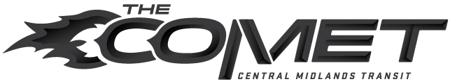

Central Midlands Regional Transportation Authority
Board of Directors Meeting Schedule 2019–2020

Board meets at:
Central Midlands Regional Transit Authority
3613 Lucius Road, Columbia, SC 29201

Upcoming Meeting Dates for fiscal year 2019-2020
Meetings occur the 4th Wednesday of the month at 12:00 p.m.*

May 22, 2019
June 26, 2019
July 24, 2019
August 28, 2019
September 25, 2019
October 23, 2019
November 27, 2019
December – No meeting
January 22, 2020
February 26, 2020

March 25, 2020
April 22, 2020
May 27, 2020

*Unless otherwise posted.

Central Midlands Regional Transportation Authority
Board of Directors

Ron Anderson, Chair

City of Columbia
Service Committee

John V. Furgess, Sr., Vice Chair
Richland County Legislative Delegate
Service Committee

Andy Smith, Secretary

Forest Acres
Finance Committee

Dr. Robert Morris, Treasurer
Richland County Legislative Delegate
Executive Director Evaluation Ad-Hoc Committee
Finance Committee

Jacqueline Boulware

Richland County
Finance Committee
Intermodal Committee

Joyce Dickerson

Richland County
Finance Committee
Intermodal Committee

Carolyn Gleaton

City of Columbia
Executive Director Evaluation Ad-Hoc Committee
Service Committee

Bobby Horton

City of West Columbia
Finance Committee

Representative Leon Howard
Richland County Legislative Delegate
Executive Director Evaluation Ad-Hoc Committee
Finance Committee

Derrick Huggins

City of Columbia
Service Committee
Intermodal Committee

Skip Jenkins

City of Cayce
Advisory Member
Finance Committee

Col. (R) Roger Leaks, Jr. Richland County
Executive Director Evaluation Ad-Hoc Committee
Service Committee

Lil Mood

Lexington County
Executive Director Evaluation Ad-Hoc Committee
Service Committee
Intermodal Committee

Kevin Reeley

Town of Springdale
Advisory Member

Geraldine Robinson

Town of Eastover
Advisory Member
Service Committee

Debbie Summers

Lexington County
Advisory Member

William (B.J.) Unthank
Lexington County Legislative Delegation
Advisory Member
Intermodal Committee

